Mini-project assignment synopsis
Project group: 3

Group participants:
Thomas Ginnerup Kristensen
Henrik Arentoft Dammand
Anders Hvidgaard Poder

Project name: Automatic sorting conveyor

Description
Much effort is spent sorting mass-produced items to get rid of the defective items. At our production line, highly transparent blocks of LEGO is produced, and the automatic sorting conveyor must weed out any blocks, which do not meet the transparency requirements.

Synopsis
A light based proximity or distance sensor is used to determine if any non-transparent blocks move down the conveyor belt. If a non-transparent block is detected, an actuator must push the block off the conveyor-belt. A non-transparent block is defined as any block that can be detected by the light based proximity or distance sensor. Every time a block is disguarded an audio-notification must sound.

Drawing
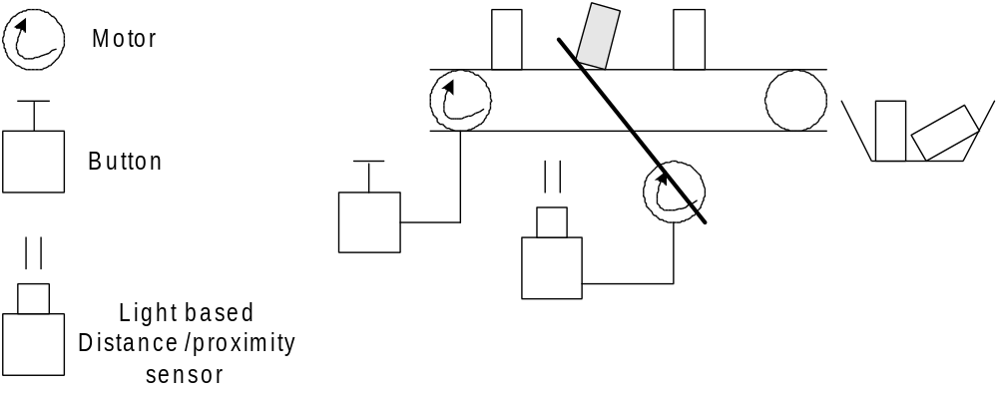

Model
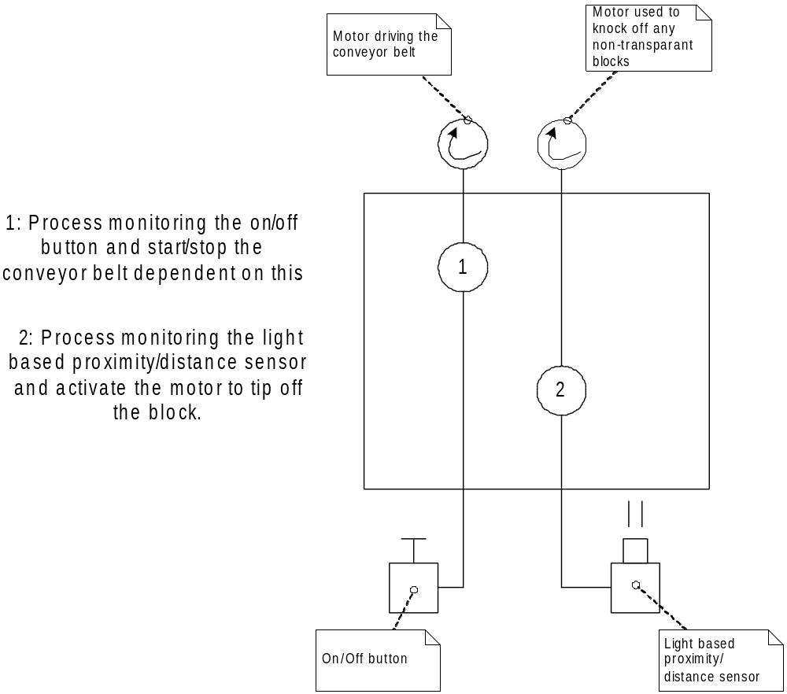

Issues of importance
In order to ensure that only the non-transparent block is rejected, it is required to determine the speed of the motor used to knock off the block relative to the speed of the conveyor belt. This can be used to calculate the location of the light based distance/proximity sensor. This relation can also be used to calculate the minimum distance that must exist between the blocks on the conveyor-belt.

We will disregard the small window of error if the conveyor belt is started or stopped with a non-transparent block between the sensor and the motor to knock it off.

Potential extensions
This system may be extended in different ways, depending on the capabilities of the sensors and the time frame.

- When a non-transparent block is disguarded it can fall on a slide that sounds an alarm to indicate that an non-transparent block was discovered. In order to avoid the sound continuing it should be a slide that it hits, to ensure only a single ping.
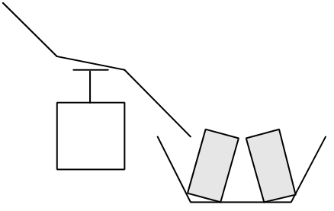
- If multiple non-transparent blocks is discovered within a given time frame the system must shut down, as then there is a problem with the production line.
- If the light based proximity/distance sensor can be configured for sensitivity, it would be possible to configure how non-transparent the blocks should be before they are disguarded.
- It would be possible to add a speed-control button to decrease or increase the speed of the conveyor belt. Naturally this will affect the distance between blocks and the speed/reaction time of the motor used to push off the blocks.
- If a block is found to be non-transparent, but the sensor registering the disguarded blocks do not register the disguarded block an alarm should sound (continuous) and the system shut down.
The model including these above extensions would look like the figure shown below.
